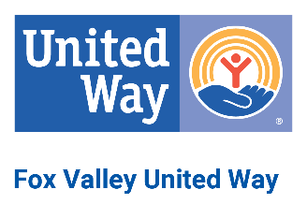

Fox Valley United Way

Board of Directors Meeting Agenda

8:30 am –10:00 am
Thursday, May 10, 2023 – Via Zoom

Call Meeting to Order

Roll Call
- Approve Minutes – March 2023
- Chairman of the Board’s Report
- Chief Executive Officer Report

- Board / Staff Strategic Plan
- Mission, Vision, and Core Values

- Engagement / Development
Women United
ALICE
- Committee Reports
Finance
February 2023
Budget
Impact / Investment
Updates

Nominating
Nominating Policy

- Program Reports
SPARK - updates
- Next Meeting Date – June 8, 2023
11. Adjournment

