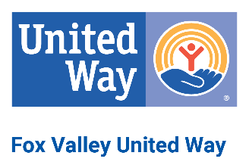

Fox Valley United Way

Board of Directors Meeting Agenda

8:30 am –10:00 am
Thursday, July 11, 2024– Via Zoom

Call Meeting to Order

Roll Call
- Approve Minutes – May 2024 and June 2024
- Chairman of the Board’s Report
- Chief Executive Officer Report

- Committee Reports

Nominating
7-24 Board of Directors Terms
FY25 Nominating Slate

Finance
5-24 Financial Statements
FY25 Proposed Budget
Impact / Investment
Proposed Allocations

- SPARK
Updates
Van

- Engagement
Kane 211
DPIL
- Development
Mayor Meetings
Brand Refresh
In-Kind Donations
- Next Meeting Date – August 8, 2024
11. Adjournment

