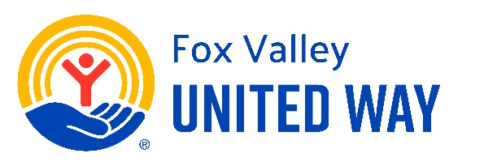
Job Title:
Community Engagement Specialist
Position Summary:
The Community Engagement Specialist will be responsible for increasing visibility, expanding awareness, and supporting impact initiatives to mobilize community members to support Fox Valley United Way's mission, vision, and core values.
This position is responsible for creating and managing a communications/outreach strategy in a way that inspires and motivates stakeholders to take action and support fundraising goals.
JOB RESPONSIBILITIES: (Essential functions of the job)

Communications / Engagement
- Implement a communication strategy to increase community awareness of impact initiatives related to Fox Valley United Way‘s Mission, Vision, and Core Values
- Support marketing strategies and materials to solicit engagement, including social media and Friday 5 Eblast
- Increase communication methods to grow relationships with donors, stakeholders, volunteers, and collaborative partners
- Collaborate with the Director of Development to support resource development strategies and goals

Fundraising Events
- Collaborate with the Director of Development to support fundraising events and experiences with specific goals and objectives for increased revenue and engagement
- Promote programs to success through procurement of resources, including in-kind donations, and volunteerism
- Support the production of marketing materials for publicity and promotion of activities and events
- Help identify and solicit sponsorships for activities and events

Campaigns
- Collaborate with the Director of Development to coordinate workplace campaign presentations, including delivery of campaign materials, scheduling of agency speakers
- Support the Director of Development in all campaign strategies
Programs
- Support impact initiatives for 2-1-1, and Dolly Parton’s Imagination Library, SPARK, and Holiday Assistance

COMPETENCIES:
To perform this job successfully, the incumbent should demonstrate the following competencies:

- Teamwork Collaboration – Understands the importance of collective communication among the team
- Excellent interpersonal skills
- Excellent verbal and written communication skills
- Quality Control – demonstrates accuracy and thoroughness and monitors own work to ensure quality.
- Adaptability – adapts to changes in the work environment, manages competing demands, and can deal with change, delays, or unexpected events
- Self-sufficient – self-directed and takes the initiative on projects

JOB REQUIREMENTS:
Incumbents must have a passion for working in a mission-driven organization.

Education:
Bachelor’s degree in communications, marketing, or related field or equivalent experience.

Experience:
- Outreach
- Events
- Fundraising

Flexibility to work occasional night and weekend hours may be required to successfully complete Fox Valley United Way activities and events.

DISCLAIMER:
This job description is intended to convey the essential functions of this position, and it is not intended to be an exhaustive list of skills, duties, responsibilities, or working conditions associated with the position.

